SVKM's NMIMS · Mukesh Patel School of Technology Management & Engineering, Mumbai
Immersive Virtual Reality & Augmented Reality (IVRAR - 702TG0C003) · AY 2026–27 Odd Semester
GROUP 14 TECHNICAL DOSSIER
Capstone ICA (20 marks): SBL Studio Project 10 · DBL Usability Case Study 5 · Studio Showcase & Viva Voce 5
Group / Batch | Group 14 · Batch B2 (as allotted in the finalised PBL titles sheet)
Monorepo folder | https://github.com/sunny-nanade/NMIMS-MPSTME-IVRAR-2026/tree/main/Group_14_Ananya_Anvay_Mahit_Aryan
Submit (3 places) | (1) PDF on MS Teams, turned in by EVERY member · (2) this filled Word file AND its PDF committed to Group_14_Ananya_Anvay_Mahit_Aryan/docs/IVRAR_Group_14_Technical_Dossier.docx / .pdf · (3) LinkedIn video URL in Section 5. Due Monday, 26-Oct-2026, 23:59 IST. Studio Showcase, Expo & Viva Voce: Saturday, 31-Oct-2026.
How to fill this file | Use Microsoft Word (desktop recommended). Choose answers from the 'Select ▾' drop-downs and type into the 'type here' fields. Do not delete or retype them, and do not edit this file in Google Docs: the drop-downs are how your answers are read.

Student name | Roll No. | SAP ID | Programme | Batch | Declared studio role
ANANYA BAWEJA | I003 | 70122400026 | B Tech (Artificial Intelligence) | B2 | Terrain & Rover Simulation Lead
ANVAY BORADE | I006 | 70122400050 | B Tech (Artificial Intelligence) | B2 | Lead AI/RL & Unity-Python Systems Architect
MAHIT NARESH DASWANI CHANCHLANI | I010 | 70122400075 | B Tech (Artificial Intelligence) | B2 | Planning, LiDAR & Integration Support
ARYAN OBEROI | I041 | 70122400039 | B Tech (Artificial Intelligence) | B2 | Testing, Benchmarks & Documentation Lead
Batch column = official student list. Tell Dr. Nanade by 20-Oct if any name, ID or role is wrong.
SECTION 1 · Autonomous Rover Navigation: Problem Bottleneck & Research Title SBL Studio Project
Implemented PBL research title | How effectively can A*-guided CNN–SAC autonomous rover control navigate rocky Mars-like terrain compared with classical planners and baseline RL controllers?
Implementation focus | Phase 1: A*, D* Lite, Hybrid A* planning; D3QN, PPO-CNN and SAC-CNN control; PyBullet training and a six-wheel Unity deployment scene with LiDAR and local obstacle detours.
Research scope / contribution | Final v1.5f adds route-progress reward, a rule-based driving teacher, actor behavior cloning, protected replay, staged curriculum and validation-based checkpoints. Any change to the faculty-approved title requires approval.

1.1 Verified research foundations: primary-source claim audit
Use primary journal/conference sources for the actual navigation methods. Claims about our performance are supported separately by the saved held-out evaluation CSVs; no synthetic or human-trial results are used.
Claim (as in title sheet) | Faculty pre-audit note | Primary source you verified (author, year, venue, DOI/URL) | Source type | Keep / Correct / Delete
A* selects search nodes by f(n)=g(n)+h(n) to find low-cost grid routes. | Classical planning basis; consistent with planners.py and our 10-map test. | Hart, Nilsson & Raphael (1968), IEEE TSSC; DOI: 10.1109/TSSC.1968.300136 | Peer-reviewed paper (DOI) | Correct
Soft Actor-Critic trains a continuous policy using maximum-entropy actor–critic learning. | Primary SAC algorithm; our v1.5f adds project-specific teacher/BC/replay. | Haarnoja et al. (2018), ICML/PMLR 80; proceedings.mlr.press/v80/haarnoja18b.html | Peer-reviewed paper (DOI) | Correct
HiRISE provides high-resolution Mars imaging for terrain mapping and elevation workflows. | NASA terrain context; our test set also uses procedural terrain. | McEwen et al. (2007), JGR Planets; DOI: 10.1029/2005JE002605 | Peer-reviewed paper (DOI) | Correct

1.2 Baseline friction in your own words (3–4 lines: who struggles, with what, how it is measured today):
Planetary rovers must reach goals across uneven slopes and rocks without collisions, wheel slip or getting stuck. Grid planners find routes, but a six-wheel vehicle also needs physical steering/throttle control. We combine terrain/LiDAR sensing, A* guidance, learned CNN–SAC control and Unity simulation; evaluate success, collisions, route progress and planner computation.

SECTION 2 · Autonomous Rover Architecture, Algorithms & Mathematical Model SBL Studio Project
Python and Unity implementation files | Python: mars_rover/planners.py, terrain.py, envs/rover_env.py, rl/{d3qn,features,protected_replay}.py; scripts/{09_train_d3qn,10_train_ppo,11_train_sac,34_generate_v15f_teacher_demos,36_train_sac_v15f,37_benchmark_sac_v15f}.py. Unity: Assets/Scripts/*.cs.
Rover actuators, sensors and telemetry | Unity RoverDrive.cs: six WheelColliders, steering/throttle/braking; LidarGridSensor.cs: 144 horizontal rays × 4 vertical angles, 32×32 obstacle grid; UnityUdpBridge.cs: status/pose/slip/goal sensor packets; V01HUD.cs: live telemetry.
End-to-end navigation pipeline | DEM/obstacle map -> slope/roughness cost -> global A* route -> moving 6 m lookahead -> local terrain and LiDAR (5×32×32) + 14-state vector -> Python SAC actor via UDP 5005/5006 -> steer/throttle -> six-wheel Unity physics; DynamicGuidanceAvoidance.cs + RuntimePathRockSpawner.cs handle runtime rocks.
Methods and governing equations | A*: f=g+h; D* Lite: rhs(s)=min[c(s,s')+g(s')]; Hybrid A*: x'=x+vΔt cosθ, θ'=θ+(vΔt/L)tanδ. D3QN: Q=V+A-mean(A); PPO: clipped ratio objective; SAC: stochastic actor + twin Q-critics, entropy term. v1.5f route reward=400Δs/L, plus safety/efficiency shaping.
Simulation and training toolchain | Unity 6000.3.23f1, C# physics and rock/terrain assets; Python 3.11, PyBullet, NumPy, PyTorch, Stable-Baselines3, Gymnasium. SAC v1.5f: teacher -> 6-epoch actor BC -> 150k regular + 30k protected replay -> staged 20–110 m missions; separate held-out test maps.

2.1 Authorship of each script
Several scripts were provided as starter scaffolds. Be honest: mark what you wrote, what you changed, and what you used as given. Viva questions will target the code you claim.
Script | Written / Modified / Used as given | Main author (Roll) | What you changed or added (1 line)
UnityUdpBridge.cs | Modified by us | Shared | Unity->Python state/LiDAR UDP packets, 6 m global waypoint, SAC actions, direct and detour-assisted control.
DynamicGuidanceAvoidance.cs | Modified by us | Shared | Local A* route detours around runtime rocks, clearance tests and teacher-consistent tracking support.
RoverDrive.cs | Modified by us | Shared | WheelCollider steering geometry, six-wheel torque, velocity limiting and braking on Martian terrain.
LidarGridSensor.cs | Modified by us | Shared | Raycast LiDAR, 32×32 occupancy mapping, near-field obstacle checks and temporary memory.

2.2 Key code snippet (≤ 25 lines) that implements your state machine or main equation:
Python: mars_rover/envs/rover_env.py, step() (selected source lines):
route_progress = float(route_s - self.prev_route_s_m)
self.prev_route_s_m = float(route_s)
cross_track_improvement = previous_deviation - float(route_deviation)
route_denom = max(float(self.reference_path_length_m), 1e-6)
reward = 400.0 * (route_progress / route_denom)
reward += 0.10 * float(np.clip(cross_track_improvement, -0.50, 0.50))
reward -= 0.004
reward -= 0.012 * slip
reward -= 0.003 * float(np.dot(action_delta, action_delta))
Unity control: UnityUdpBridge.cs -> RoverDrive.cs -> WheelColliders.

2.3 Equation derivation and one worked example with your own numbers and units:
Planning: A* uses f(n)=g(n)+h(n); e.g., g=12, h=8 gives f=20 cost units. Hybrid A*: x'=x+vΔt cosθ, θ'=θ+vΔt tanδ/L, where v is m/s and Δt is s. SAC critic target: y=r+γ[min(Q1',Q2')-α log π(a'|s')]; actor chooses high-Q steering/throttle while maintaining entropy. Behavior cloning: L_BC=(1/N) Σ||π(s)-a_teacher||². In v1.5f, r_route=400 Δs/L; e.g., Δs=5 m on a 100 m path gives +20 route-progress reward BEFORE penalties. Global guidance tracks an A* waypoint ~6 m ahead. Source: rover_env.py; 36_train_sac_v15f.py; UnityUdpBridge.cs.

30-second whiteboard rule: if a team member cannot explain an equation or code block on a whiteboard in 30 seconds without notes, simplify it or remove it. It will be asked in the viva.
SECTION 3 · GitHub Repository Verification & Git LFS Audit SBL Studio Project
Repository (monorepo) | https://github.com/sunny-nanade/NMIMS-MPSTME-IVRAR-2026
Your group folder | Group_14_Ananya_Anvay_Mahit_Aryan/
Filled dossier location | Group_14_Ananya_Anvay_Mahit_Aryan/docs/IVRAR_Group_14_Technical_Dossier.docx
Release tag / measurement status | TBD

Final commit hash (full 40 characters) | TBD
Release build link (.apk / .exe) | https://drive.google.com/file/d/1QafNwGF8TsHTe0JKiX7MdWxgiQ-uJhe0/view?usp=sharing
Root .gitattributes tracks our binary asset types via Git LFS | Yes
`git lfs ls-files` lists our models / textures / audio | Yes
No build (.apk / .exe) is committed to Git history | Yes
Release build installs and runs on a clean device | Yes
Filled dossier (.docx + .pdf) committed to docs/ | Yes

3.1 Repository telemetry for your folder (run from the repo root; type the numbers)
Metric | Command | Value
Commits touching your folder | git log --oneline -- Group_14_Ananya_Anvay_Mahit_Aryan/ | wc -l | 11
Branches used by your group | git branch -r --list '*group-14*' | wc -l | 1
Lines of C# code | find Group_14_Ananya_Anvay_Mahit_Aryan -name '*.cs' | xargs cat | wc -l | 7220
Total folder size (MB) | du -sm Group_14_Ananya_Anvay_Mahit_Aryan | 465.44 MB
LFS-tracked files in your folder | git lfs ls-files | grep Group_14_Ananya_Anvay_Mahit_Aryan | wc -l | 110
Participant CSVs (not RL results) | Count actual HUMAN study CSVs in telemetry/ (exclude SIMULATED_*) | 0

3.2 Individual contribution (shared Git upload; verify per-author commits before marking)
Member | GitHub username | Commits | % effort (agreed) | Main contribution (files / features)
Ananya Baweja (I003) | type here | Shared | 100 | Terrain/model asset organization and environment checks;
Anvay Borade (I006) | anvayborade | Shared | 100 | Python RL/model training, navigation algorithm integration, Unity/Python bridge
Mahit Naresh Daswani Chanchlani (I010) | type here | Shared | 100 | LiDAR, local planning and integration testing support;
Aryan Oberoi (I041) | type here | Shared | 100 | Benchmark protocol, documentation, demonstration/test evidence;

SECTION 4 · Autonomous Rover Benchmark & Empirical Data Pack DBL Evaluation Case Study
Primary experimental metrics | Physical rover: goal success/collision/stuck, normalized route progress, episode steps. Planners: grid route success, path length, nodes expanded and CPU planning time. RL test run: 28-Oct-2026.
Evaluation units / test terrains | 10 held-out test maps (2 easy, 4 medium, 4 hard); 2 fixed-seed PyBullet episodes/map = 20 per learned policy; classical algorithms benchmarked on 10 grids. No human participants.
Algorithms and comparisons | Planners: A*, D* Lite, Hybrid A*. RL: A*+D3QN, PPO-CNN, baseline SAC, v1.5f BEST and v1.5f 1M. Legacy RL versus v1.5f use DIFFERENT native reward/observation contracts; only best vs final is closely matched.
Main findings / significance | All planners found paths on 10/10 grids. Mean planning time: A* 115 ms, D* Lite 1,138 ms, Hybrid A* 2,749 ms. v1.5f BEST: 14/20 goals, 0/20 collision endings; FINAL 1M: 4/20 goals, 5/20 collision endings. Python results, not Unity success rates.

Held-out PyBullet episodes (per policy) | 20 rover episodes per RL model (0 people)
Study design (simulation) | Select ▾
Test date and environment | 28-Oct-2026; local PyBullet Python run; 10 held-out terrain maps, 2 fixed-seed episodes each.
Real evaluation CSV location | LOCAL evaluation ZIP: ppt_phase1_evaluation/tables/{rl_episode_level,rl_model_summary,classical_planner_summary}.csv; copy to Group14/telemetry for Git reproducibility.

Measure (PyBullet) | N | Mean | SD | Median | Condition / comparison
Goal success: v1.5f best | 20 | 70% | N/A binary | N/A binary | 14/20 goals; same v1.5f test contract
Goal success: final 1M | 20 | 20% | N/A binary | N/A binary | 4/20 goals; 1M final checkpoint
Collision endings: best | 20 | 0% | N/A binary | N/A binary | 0/20 collisions; final = 5/20 (25%)

Goal/collision % — actual PyBullet episodes  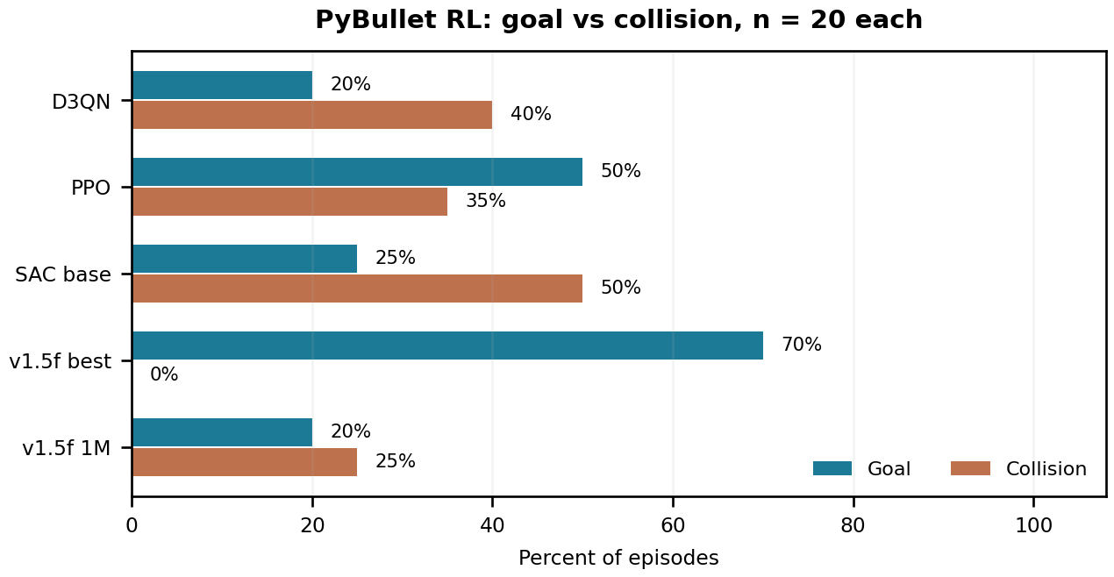 | Planner time — actual held-out grids  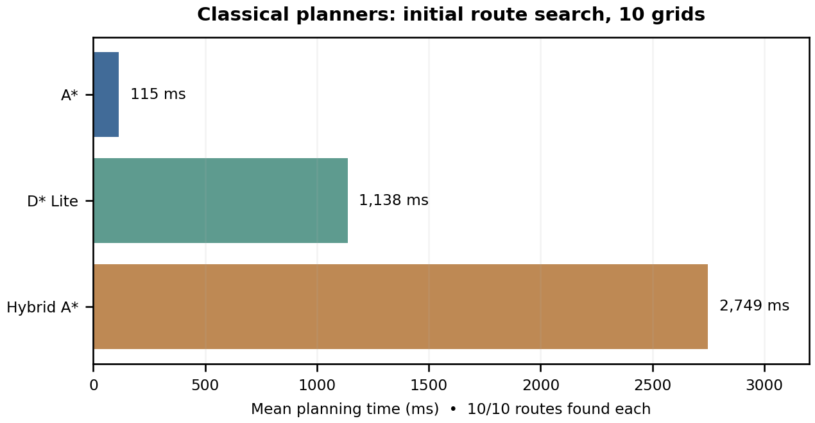

DATA PROVENANCE DECLARATION (mandatory). Navigation graphs use the real held-out CSVs, not faculty SIMULATED_* examples. No results here are collected from people.
Section 4 navigation statistics are from actual PyBullet model evaluations | Yes
No synthetic or faculty scaffold CSVs are presented as measured rover results | Yes
Human-subject usability experiment claimed or participant consent needed | No
The plotted numbers correspond to the supplied per-model and planner CSVs | Yes

SECTION 5 · LinkedIn Video Showcase, AI Verification Audit & Peer Review Studio Showcase & Viva Voce
LinkedIn post/google drive URL | https://drive.google.com/drive/folders/104tNtQzvyat9sF3vCiVKuesc9npakUq5?usp=sharing
Video length (mm:ss) | 4 Minutes
Every member appears and speaks in the video | Yes

5.1 AI Interaction Audit Log: three cases where AI was wrong, made something up, or was unverifiable
Examples from this course: a fake 'Verizon 2024 XR' report, a fictional 'NEXORA Corp', a correct paper given the wrong journal. Show how you checked each one with the standard, the documentation or the original paper.
# | AI tool | What we asked & what AI said | How we caught it | What was actually true (with source) | Error type | Verdict
AI-01 | ChatGPT | Suggested copying mars_rover/ relative to Git clone root; source absent there. | Ran / tested the code | Correct source: Group_14_Ananya_Anvay_Mahit_Aryan/Phase1/Python/mars_rover/. PowerShell Copy-Item error verified. | Other | Corrected
AI-02 | ChatGPT | Earlier setup documentation assumed Unity 2022.3 LTS from faculty scaffold. | Official documentation | Actual uploaded ProjectSettings/ProjectVersion.txt states Unity 6000.3.23f1. | Other | Corrected
AI-03 | Select ▾ | type here | Select ▾ | type here | Select ▾ | Select ▾

5.2 Peer review: watch both assigned LinkedIn videos and score them (0–2 per criterion)
Group reviewed | Problem | Build | Data | Honesty | Clarity | Best moment (mm:ss) | One question for the viva
Group 15: Mansi, Padminish, Jay, Aaryaman | 2 | 2 | 2 | 2 | 2 | 2:39 | NA
Group 05: Sakshi, Aryan | 2 | 2 | 2 | 2 | 2 | 1:29 | NA

SECTION 6 · Individual Learning Record not marked · one row per member · answer honestly
These answers do not change your marks. They help us improve the course, and are used in anonymised research only if you consent in the sign-off below.
Member | Hours I spent (total) | My declared role matched my actual work (1 = not at all, 5 = fully) | Before this course I had used… | Before this course I had tested with real users | I learned a skill from a teammate of another programme | Share of my writing first drafted with AI | Wrong AI facts / citations I personally caught
Ananya Baweja (I003) | 48 | 5 | Git and Git LFS | No | Yes | 76–100 % | 6 or more
Anvay Borade (I006) | 48 | 5 | Git and Git LFS | No | Yes | 76–100 % | 6 or more
Mahit Naresh Daswani Chanchlani (I010) | 48 | 5 | Git and Git LFS | No | Yes | 76–100 % | 6 or more
Aryan Oberoi (I041) | 48 | 5 | Git and Git LFS | No | Yes | 76–100 % | 6 or more

Member | The most valuable thing I learned (one line) | One thing I would change in this course (one line)
Ananya Baweja (I003) | type here | type here
Anvay Borade (I006) | type here | type here
Mahit Naresh Daswani Chanchlani (I010) | type here | type here
Aryan Oberoi (I041) | type here | type here

Track A: how this dossier becomes your 4-page IEEE paper
I. Introduction | Motivation: obstacle-rich terrain, feasible routes and physically safe autonomous motion.
II. Related work | Primary literature: Hart/A*, Koenig/D* Lite, Dolgov/Hybrid A*, Schulman/PPO, Haarnoja/SAC.
III. System design | Python/PyBullet train/test plus Unity 6-wheel scene, LiDAR grid, UDP bridge, route-guided SAC and runtime local detours.
IV. Evaluation | Measured 10-map planner tables and 20-episode controller metrics: best SAC 70% success, final 1M 20%.
V. Discussion & limitations | Different RL test contracts, limited seeds, sim-to-sim transfer not quantified, and best-vs-final policy degradation.
Target venues (title sheet) | Navigation/RL robotics paper topic; actual target venue and faculty research-title approval must be confirmed.

Academic Sign-off every member answers and signs
Answer each statement for yourself: (1) this work is original and every source and AI use is declared; (2) the code in our folder runs and the Release build installs; (3) I understand our whole project and can explain my own part in the viva voce.
Member (Roll) | (1) Original work | (2) Code runs | (3) Viva-ready | Signature | Optional research consent*
Ananya Baweja (I003) | Yes | Yes | Yes | 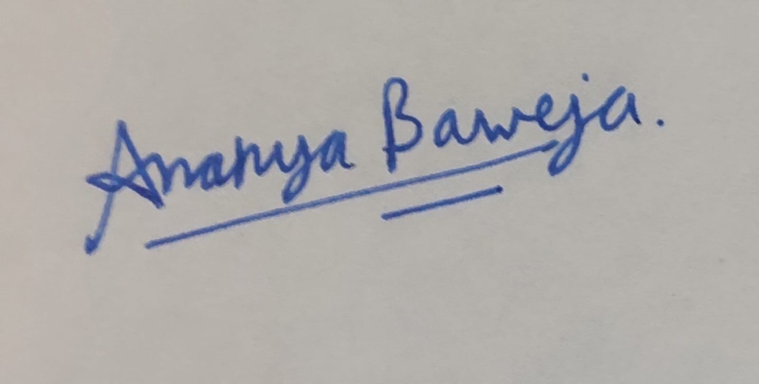 | Yes
Anvay Borade (I006) | Yes | Yes | Yes | 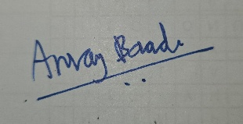 | Yes
Mahit Naresh Daswani Chanchlani (I010) | Yes | Yes | Yes |  | Yes
Aryan Oberoi (I041) | Yes | Yes | Yes | 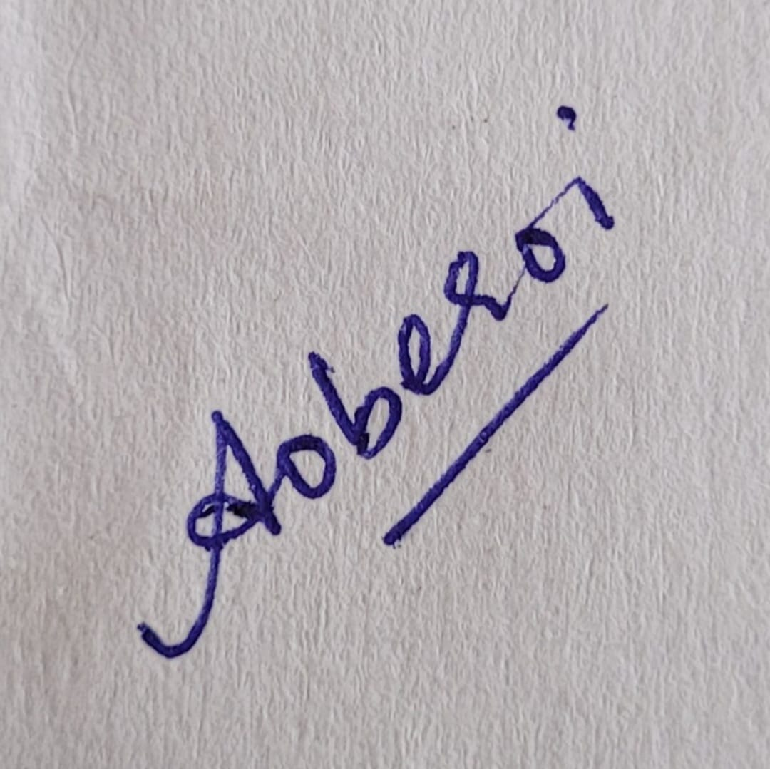 | Yes
*Optional: may Dr. Nanade use anonymised data from this dossier and repository in education research publications? Your answer has no effect on your marks, and you can withdraw until results are published.

